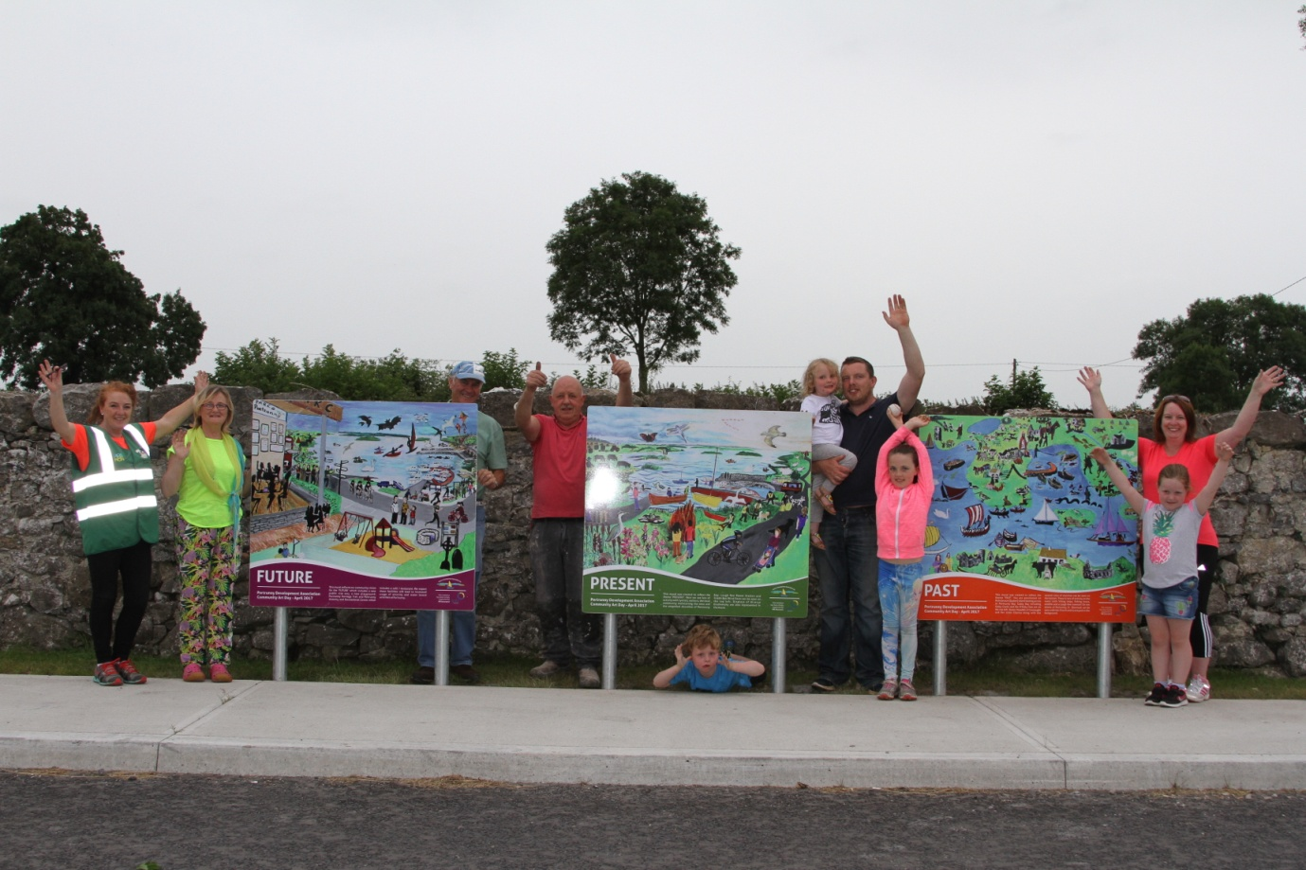

Portrunny Community Art Mural

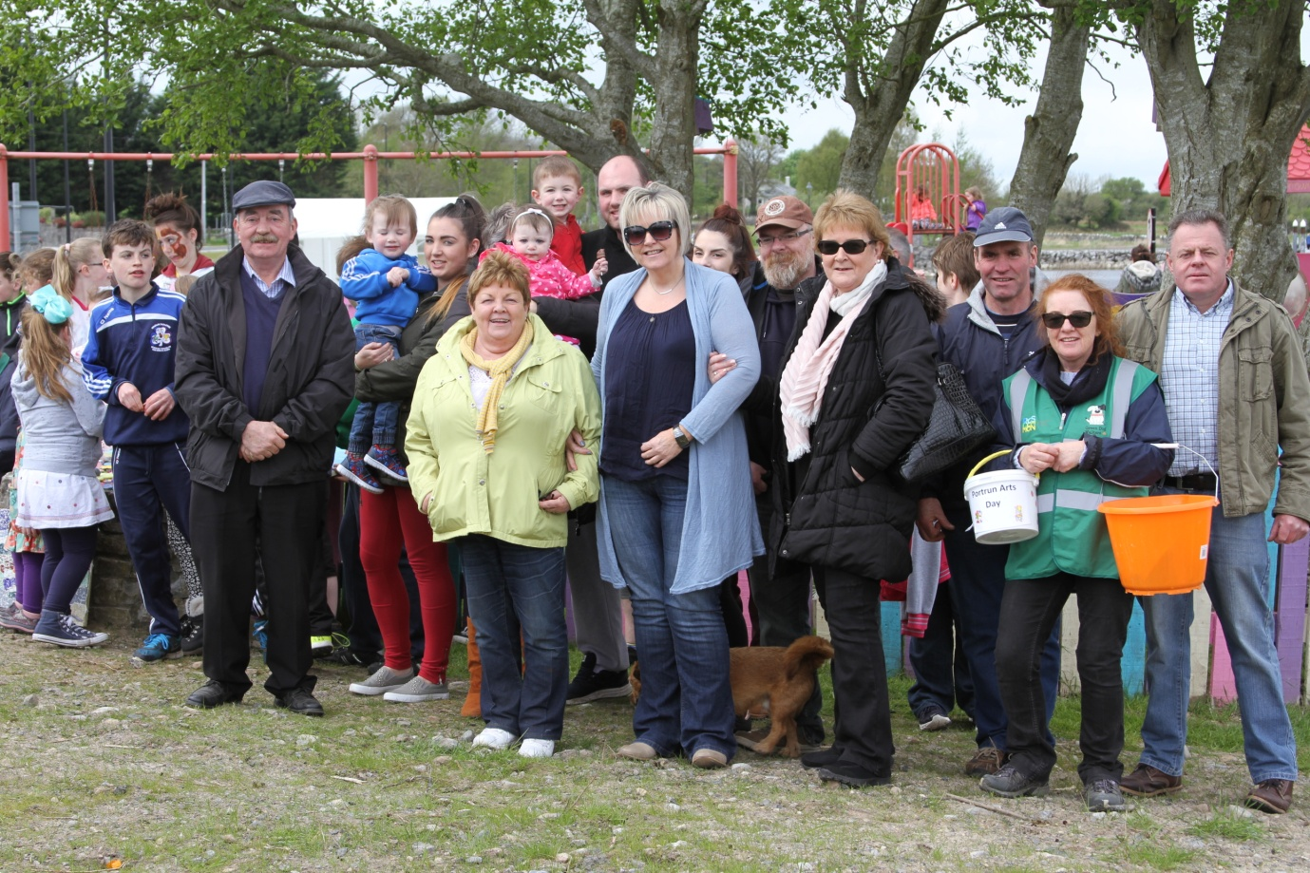

Participants in Portrunny IPB Community Art Day 2017